**Model Development**

**TOTAL POINTS 6**

1.Question 1

If the predicted function is:

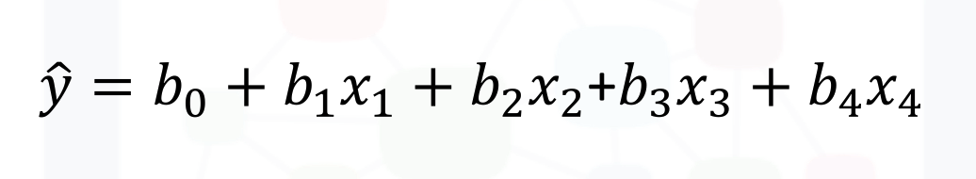

The method is:



Polynomial Regression



Multiple Linear Regression

1 point

2.Question 2

What steps do the following lines of code perform?



1

2

3

4

5

6

7

Input=[('scale',StandardScaler()),('model',LinearRegression())]

pipe=Pipeline(Input)

pipe.fit(Z,y)

ypipe=pipe.predict(Z)



Standardize the data, then perform a polynomial transform on the features **Z**



Find the correlation between **Z** and **y**



Standardize the data, then perform a prediction using a linear regression model using the features **Z**and targets **y**

1 point

3.Question 3

We create a polynomial feature as follows "**PolynomialFeatures(degree=2)**"; what is the order of the polynomial?



0



1



2

1 point

4.Question 4

What value of **R^2** (coefficient of determination) indicates your model performs best?



-1



1



0

1 point

5.Question 5

Consider the plot of one independent and one dependent variable. This is an example of what?

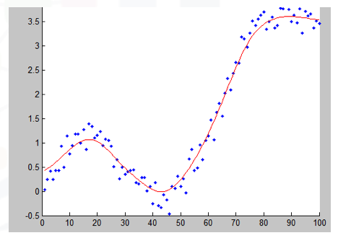



Polynomial Regression



Multiple Linear Regression



Linear Regression

1 point

6.Question 6

Consider the following equation:

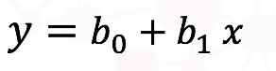

What is the parameter **b_0** (b subscript 0)?



The predictor or independent variable



The target or dependent variable



The intercept



The slope

1 point